**Hoodie (no zip) £22.50**

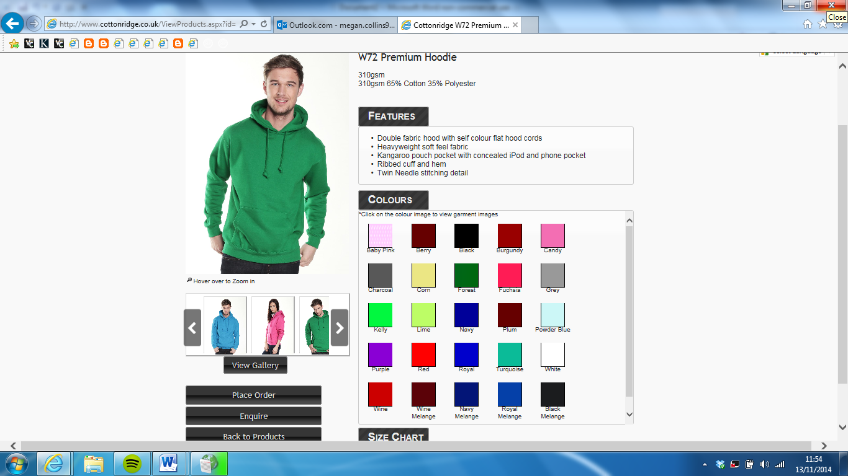

**Design:** Left breast = embroidered KCL crest with individual name embroidered below, Back = KCL Dance Soc logo

**Zipped hoodie £26.99**

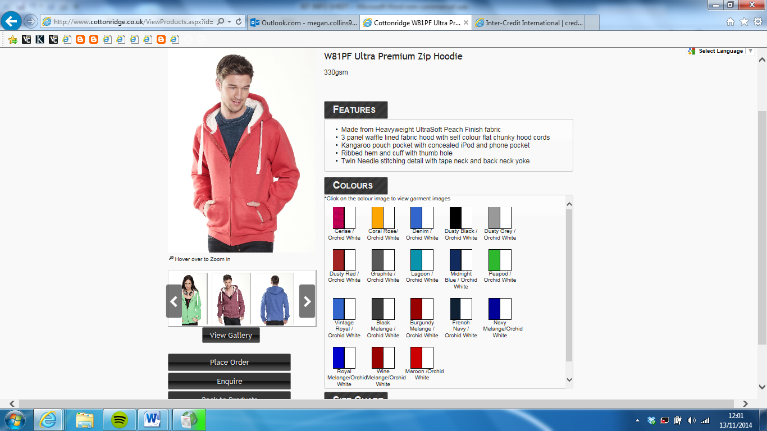

**Design:** Left breast = embroidered KCL crest with individual name embroidered below, Back = KCL Dance Soc logo

**Sweatshirt £24.50**

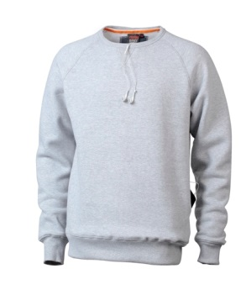 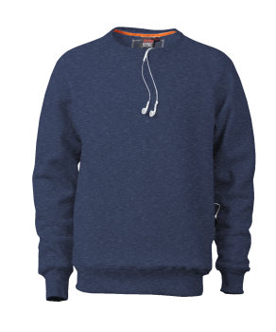 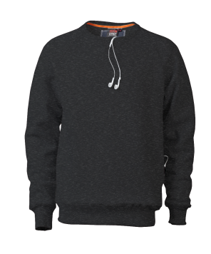 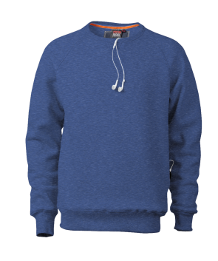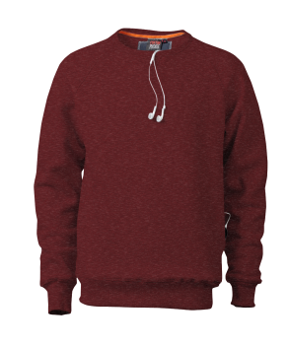

**Grey Navy Black Royal Blue Burgundy**

**Design:** Left breast = embroidered KCL crest with individual name embroidered below, Back = KCL Dance Soc logo

**Jog pants £17.99**

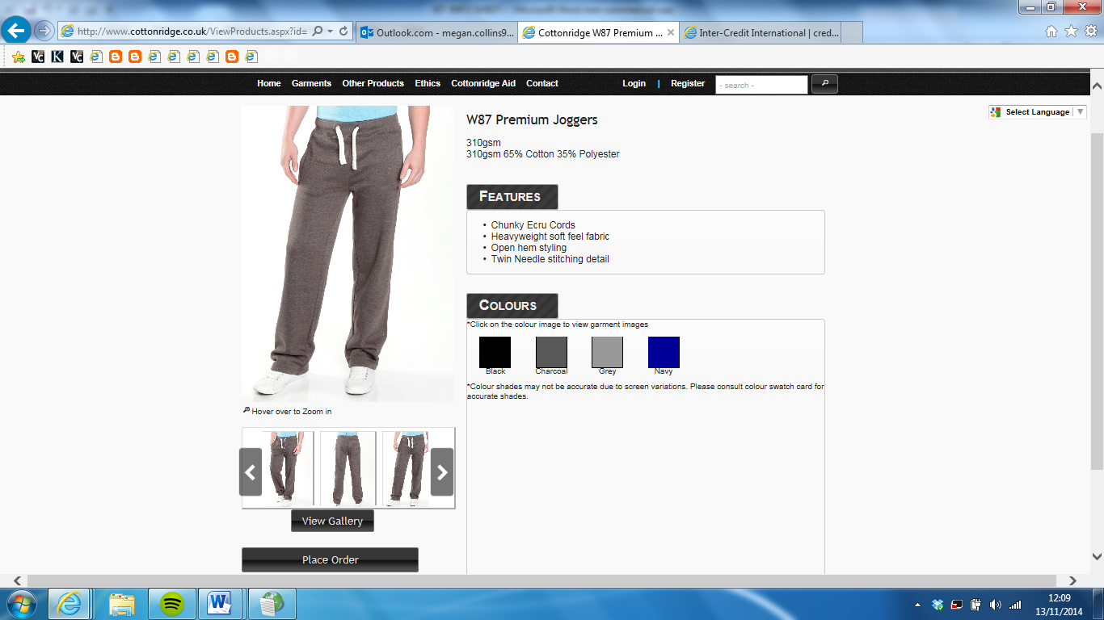

**Design:** Left leg = individual name, Buttock = KCL Dance Soc logo

**Ladies dance trousers £21.25**

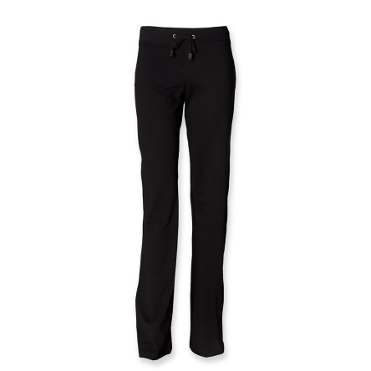 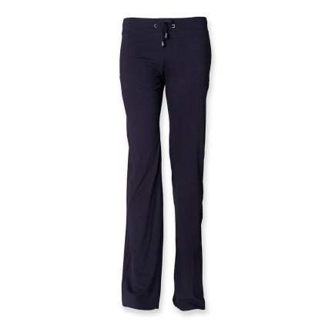

**Design:** Left leg = individual name, Right leg = KCL Dance Soc logo